MACH4METAL

metalworking machinery
Transito 21
6909 DA BABBERICH Netherlands
Tel. +31 (0)316-247123
Fax: +31 (0)316-247956
info@mach4metal.com
www.mach4metal.com

Bank No : 66.52.13.883
IBAN : NL33 INGB 0665 2138 83
BIC : INGBNL2A

SCHIAVI Press brake 3.000 x 100 T
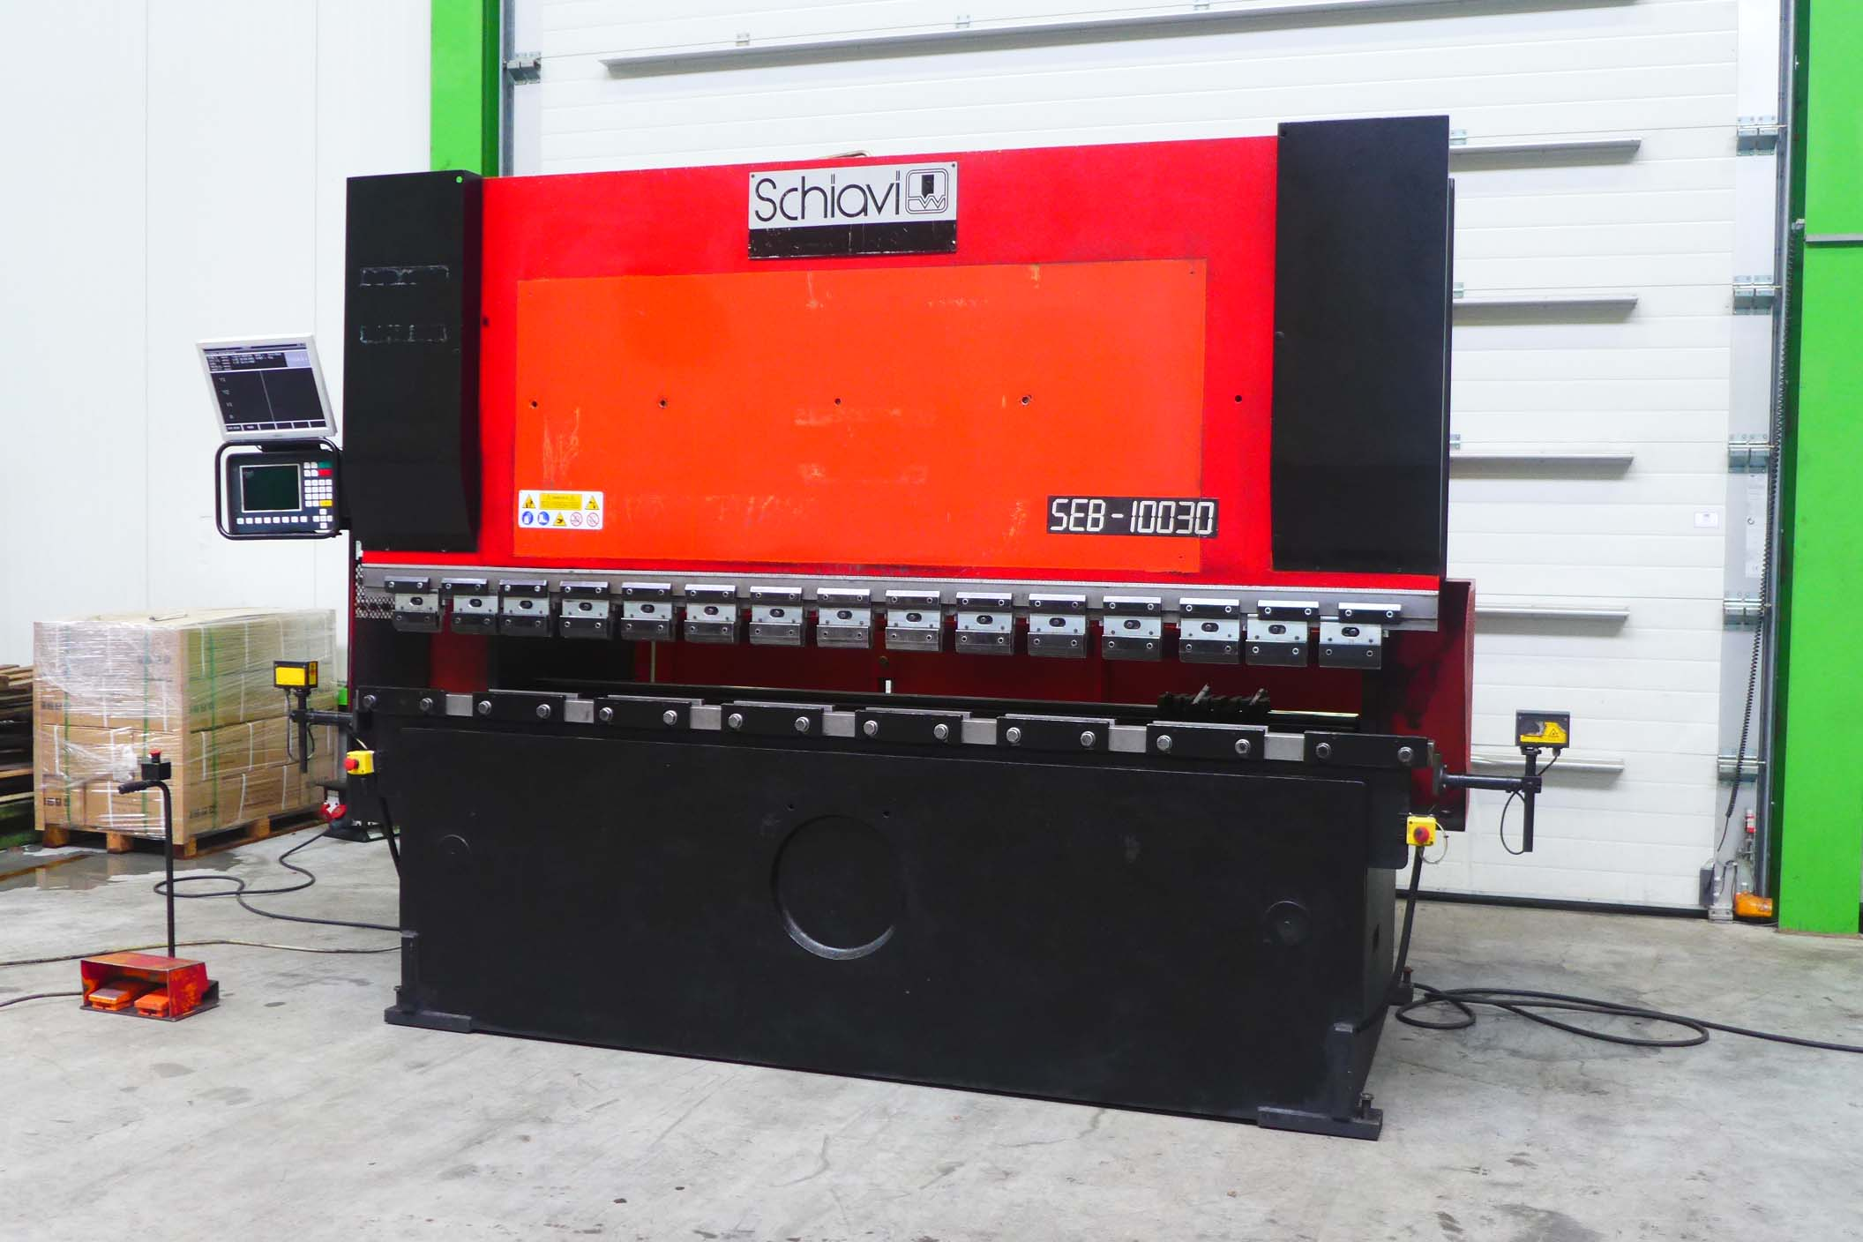
- Make : SCHIAVI Italia AMADA
- Typ : SEB
- No : 88 - 8659
- Age : 2001

- Max. bending length: 3.140 mm
- Between column : 2.700 mm
- Max. force : 100.000 Kg

- Dis. Beam – table : 350 mm
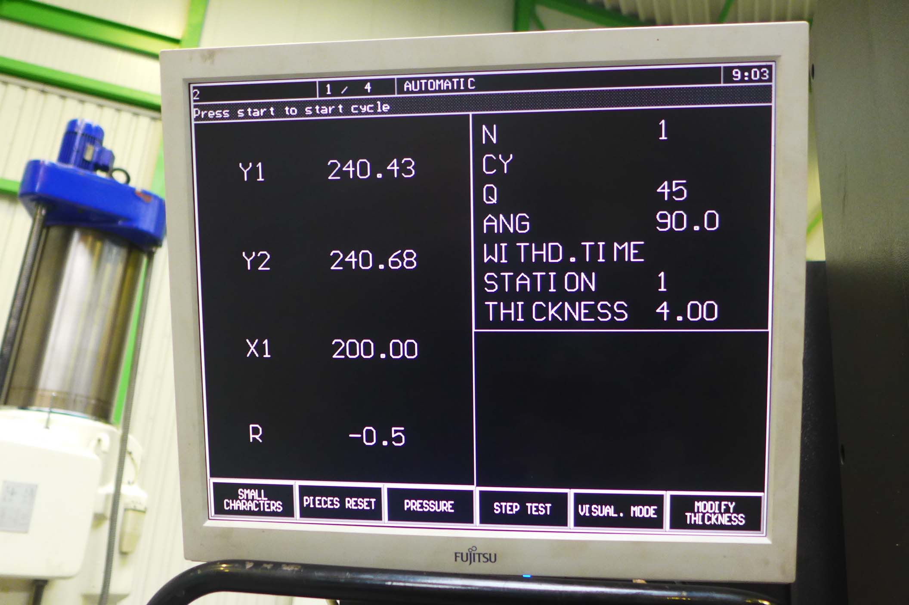
- Beam stroke : 105 mm
- Table width : 90 mm
- Troth beam : 405 mm
- Table height : 995 mm

- Approach speed : 100 mm/m
- Bending speed : 10 mm/min
- Return speed : 100 mm/min

- Dimensions
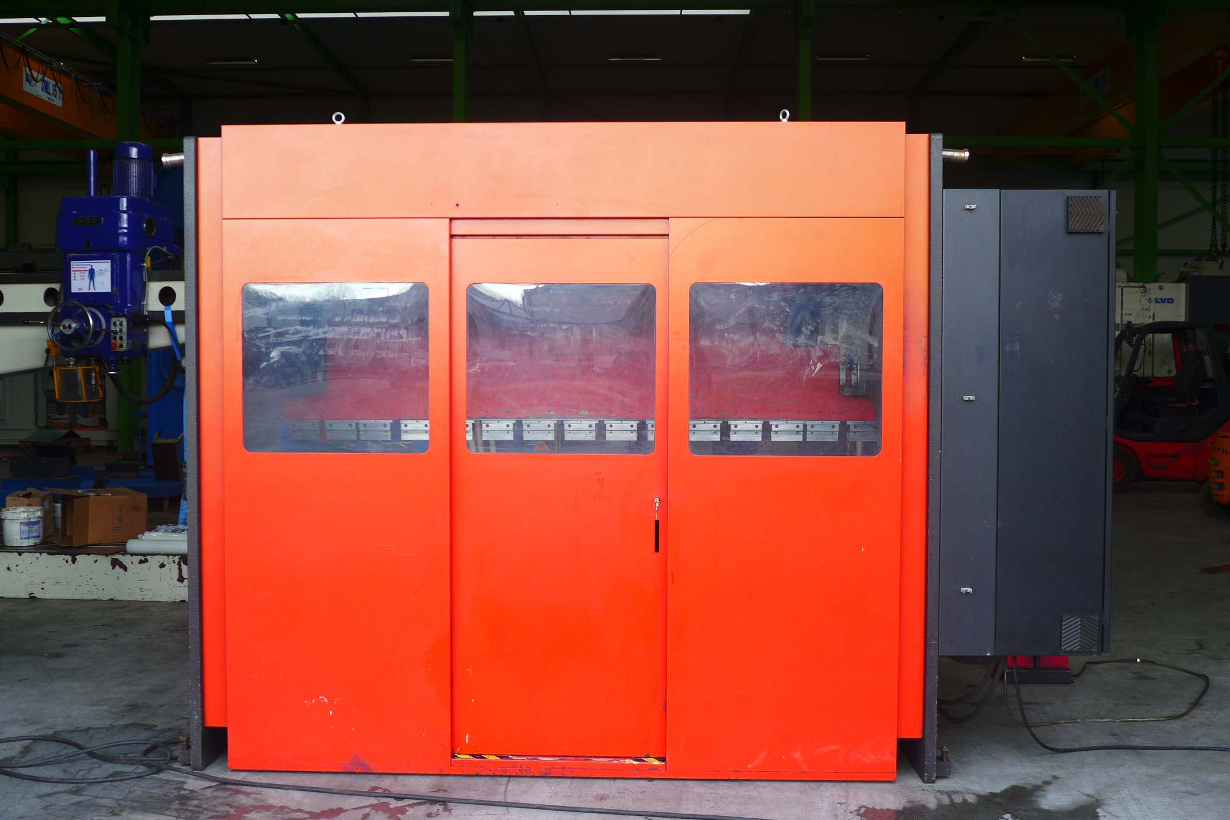
- Length : 4.360
- Width : 1.607
- Height : 2.400
- Weight : 6.500 Kg
- Power : 7.5 Kw

- TASK 64 Back gauge
- Controlled axis Y1 / Y2 / X / R

Please Note: The above information has been obtained to the best of our ability and belief from, and from the manufacturers where possible. It is given in good faith, but its accuracy can not be guaranteed. Accordingly, it will not form a representation or constitute contractual terms. We advise you to check any vital details!

